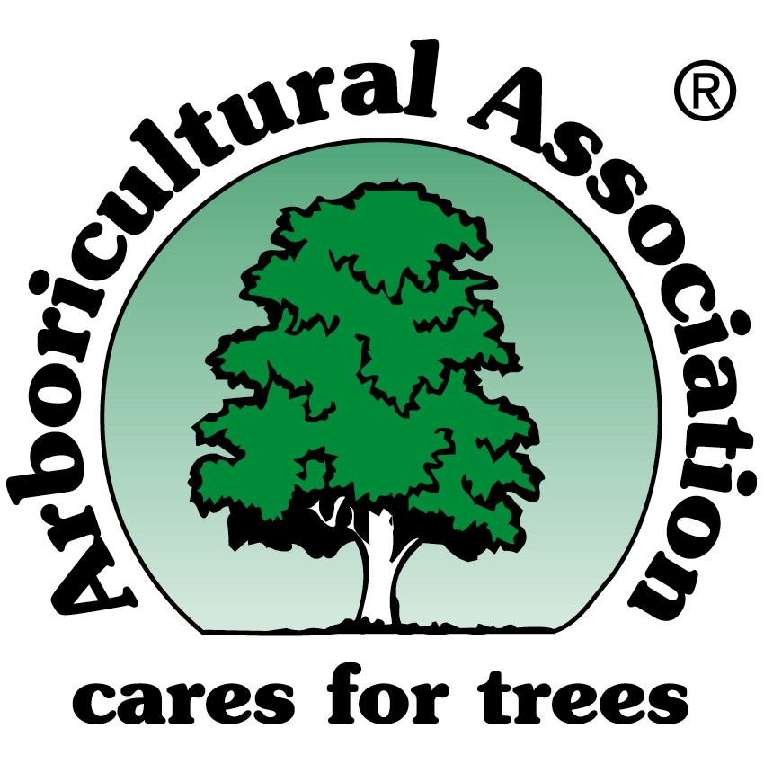

TREES and BATS
Arboricultural Association Guidance Note 1 (Second Edition), May 2003

This new and authoritative work is an essential reference tool for anyone dealing with trees and/or bats. Author Andrew Cowan of ArborEcology Ltd. (www.arborecology.co.uk) is an arboriculturist specialising in tree ecology, wildlife legislation (in the UK) and is licensed by English Nature to survey and handle bats.

The purpose of this Guidance Note is to provide information and advice in respect of bats, their conservation and habitat management within the UK. Legal aspects are discussed, and the framework of national policy and international obligations are explained.

The Guidance Note considers bats and arboriculture in relation to the planning process and development control, also best practice for management and, where necessary, the removal of trees with potential to provide bat habitat.

The document is an essential reference for local authority arboricultural officers, arboricultural and ecological consultants, arboricultural and conservation contractors, land and estate managers, licensed bat workers and concerned members of the public.

Now available at £12.50 (plus £1.00 P&P) = £13.50

TO RECEIVE YOUR COPY FAX BACK YOUR ORDER

□ Switch (see below) □ Credit Card (see below) □ Cheque attached (post only)
□ Direct Debit (only available if you have an existing DD with the AA) □ Local Authority Order Number
□ Please invoice (only available to AA account holders or Local Authorities: if you want to be invoiced and don’t already have an account telephone 01794 368717). Invoice address if different from delivery address:

(□ If Local Authority please insert Order Number ………………………………………………………)
If paying by card insert card details as follows:
Expiry Date _ _ / _ _ Issue No (Switch only) _ _ / _ _

Signed ……………………………………… PRINT ………………………………..……………
We accept: MasterCard, Visa, Visa Delta, Switch, Amex
Name …………………………………………… Delivery Address…………………………………...

………………………………………………………………………………………………………………..

Postcode …………………………………………… No copies @ £13.50 each inc. P&P ………………..

Please tick either : □ 4 hole punched, or □ bound (white plastic comb binding)

Tel …………………………………………… Mobile …………………………………...

Arboricultural Association, Ampfield House, Ampfield, Romsey, Hants. SO51 9PA.
Tel 01794 368 717; Fax 01794 368 978; email admin@trees.org.uk website www.trees.org.uk

